

**Assignment Of**

**ITEC-517 Computer Graphics(LAB)**

**LAB-TASKS**

**Submitted To:**

**Sir.Jawad Hussain Awan**

**Professor Dept:**

**Information Technology**

**Submitted By:**

**Mubashir Ali S/O**

**Mansoor Ali**

**(2k20/ITE/73) Group(A)**

**LAB-TASKS**

**Task:1**

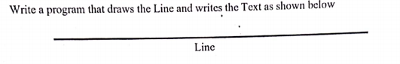

***Source Code:***

#include<graphics.h>

#include<iostream.h>

#include<conio.h>

void main()

{

int gd=DETECT,gm;

initgraph (&gd,&gm,"c:\\tc\\bgi");

line(180,20,480,20);

cout<<"\n\n\t\t\t\t\tLine";

getch();

}

***Output:***

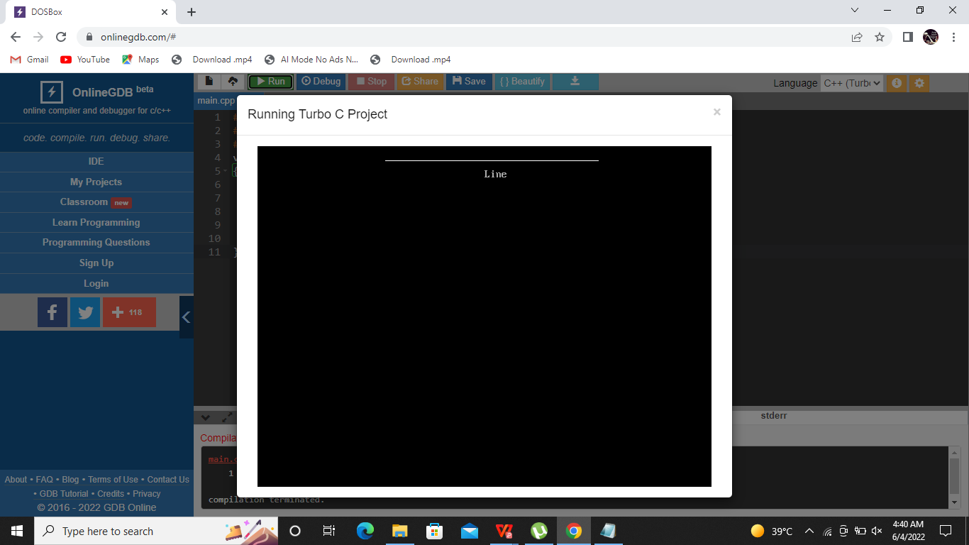

***Task:2***

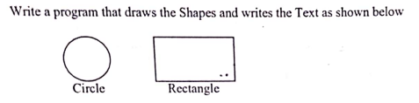

***Source Code:***

#include<graphics.h>

#include<iostream.h>

#include<conio.h>

void main()

{

int gd=DETECT,gm;

initgraph (&gd,&gm,"c:\\tc\\bgi");

circle(60,150,50);

rectangle(150,100,350,200);

cout<<"\n\n\n\n\n\n\n\n\n\n\n\n\n Circle\t\t Rectangle";

getch();

}

***Output:***

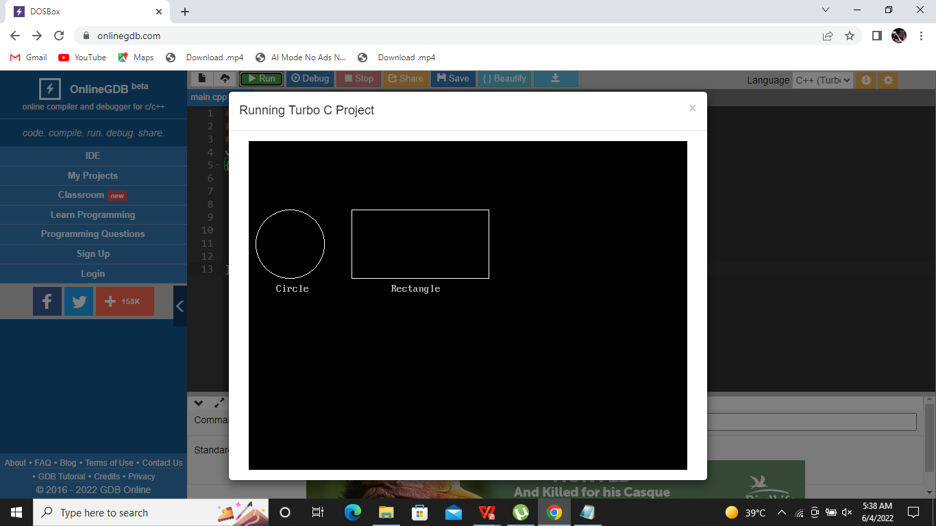

***Task:3***

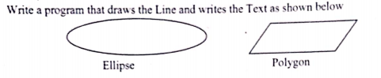

***Source Code:***

#include<graphics.h>

#include<iostream.h>

#include<conio.h>

void main()

{

int gd=DETECT,gm;

initgraph (&gd,&gm,"c:\\tc\\bgi");

cout<<"\t\n\n\n\n\n\n\n\n\n\n\n\n\n\n\n\n\n\t\tEclipse\t\t\t\t\tPolygon";

ellipse(150,200,0,360,140,50);

setlinestyle(0,0,1);

line(430,170,600,170);

setlinestyle(0,0,1);

line(400,210,570,210);

setlinestyle(0,0,1);

line(600,170,570,210);

setlinestyle(0,0,1);

line(430,170,400,210);

getch();

}

***Output:***

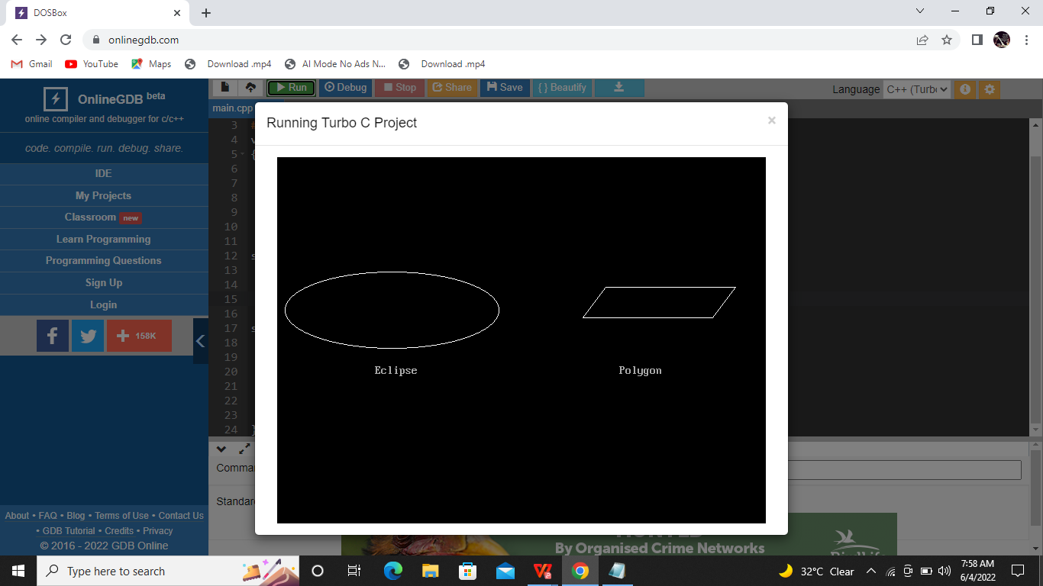

***THE END***